**World Quant University**

**Professor: Ritabrata Bhattacharyya**

**Alpha Design II**

Nikolas Lippmann Pareschi - [nikolaslippmann@gmail.com](mailto:nikolaslippmann@gmail.com)

Introduction: Spyder PEP8 checker is truly a time saver, as I discovered reading the Piazza forum in Python 2. So, I have used it again for all classes and this Project I from Alpha Design II. I tried my best to avoid using modular code.

**Project: High Frequency Index Composition Arbitrage**

Index arbitrage is driven by the relative mispricing of indexes and their underlying components. We will try to develop a simple index composition arbitrage strategy in the High Frequency domain

* + - 1. Choose a sectoral index and all of its constituent stocks

I have chosen SP500. .

* + - 1. Download/access 1 min stock data from an appropriate financial website such as Google Finance, Yahoo Finance, Quandl, CityFALCON, or another similar source.

I downloaded 1 minute intraday data from

<https://www.quandl.com/databases/AS500/documentation/sample-data>

The csv must be saved in the working Python directory

* + - 1. Using historical data check the stocks for correlation w.r.t its Index and identify the one with the strongest relationship

First we needed to do some things, like reading the data and some dataframe manipulations. We created an In sample environment to rank correlations. We use the highest correlated stock to the SP500 in the in sample Data to do the arbitrage in the Out Sample data:

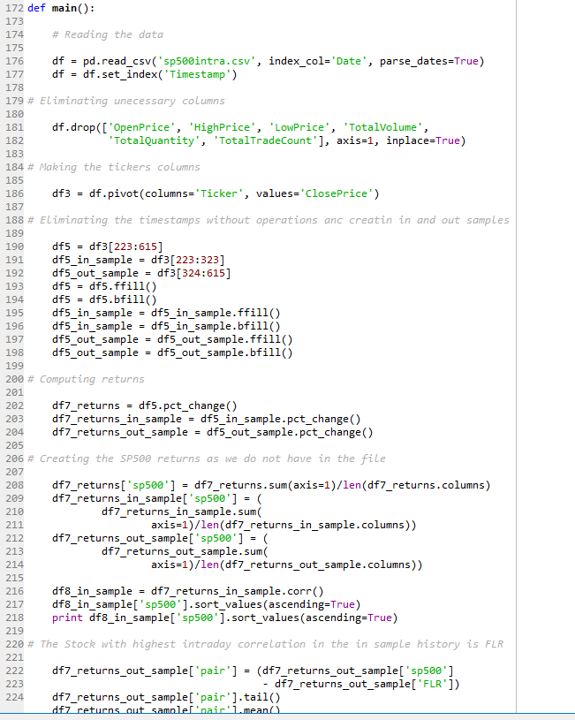

* + - 1. Device a pairs trading strategy on the 1 minute timeframe when the index and its constituent stock moves out of sync with each other (Short one and go long the other). Focus should be the simplicity of code and fast execution.

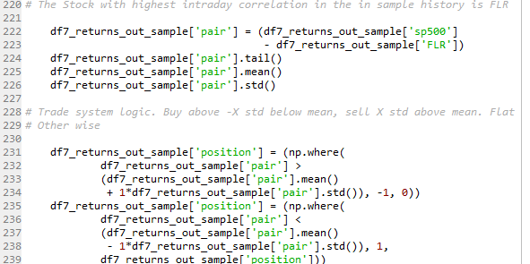

* + - 1. Exit trade when relationship mean revert

This is done in the zero case in the conditions above.

* + - 1. Consider Equal amount invested for every trade

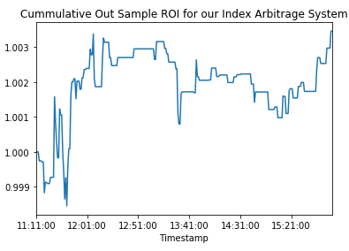

* + - 1. Clearly mention and explain all trading rules

The rules are simple, if the spread between the stock and the SP500 is above 1 standard deviation of its mean we sell, if it is below 1 standard deviation we buy. We stay flat between -1 and 1. This is the positioning for the strategy:

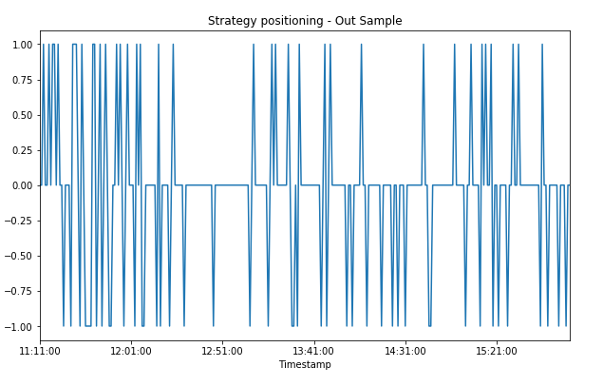

* + - 1. Estimate historic performance for such a system in out of sample data and calculate all the relevant KPIs as marked below

Win %

Win to Loss Ratio

Mean Return Per Trade

Maximum Consecutive Losers

Maximum Drawdown

CAGR

Lake Ratio

Gain to Pain Ratio

We have used the class provided by Steven Stelk in piazza in his class: Risk Management. We needed to convert the timestamp to timeindex to use the class.

